Documentation

1. Design user interface

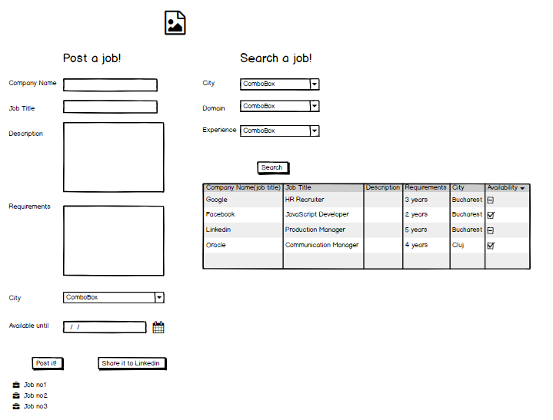

2.IDENTIFY COMPONENTS

1. Domain List
2. Job List
3. Job Search
4. Experience List
5. Availability check
6. Job display

3. Identify API Calls

1. Get /City
2. Get /Domain
3. Get /Experience
4. Get /Job/Search
5. Put /Job/ID
6. Post /Job
7. Post/Job/Linkedin

4. Define User Actions

1. View City ComboBox
2. Search by Domain
3. Search by City
4. Search by Experience
5. Set job requirements
6. Add job
7. Share to Linkedin